No. | Answer
a K = 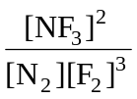
b K = 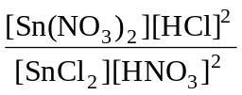
c K = 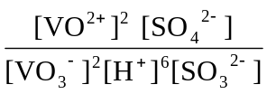
d K = 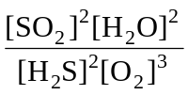
a Reactants favoured.
b Products favoured.
c Not strong in either direction, but products somewhat favoured.
a K = 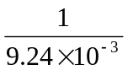 = 108
b K = (9.24 × 10^{–3})² = 8.54 × 10^{–5}
 | K = 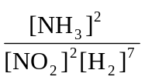 = 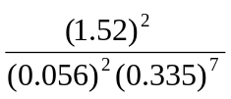 = 1.56 × 10⁶
K = 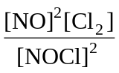 = 1.60 × 10^{–5}
∴ [NO]² = 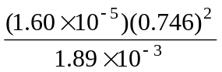 = 0.004 71
∴ [NO] = 0.0686 mol L^{–1}
K = [Ba²⁺][SO₄^{2–}] = 1 × 10^{–10}
∴ [Ba²⁺] = [SO₄^{2–}] = 1 × 10^{–5} mol L^{–1}
K = 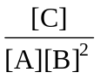 = 0.0812
∴ [B]² = 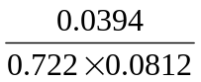 = 0.672
∴ [B] = 0.820 mol L^{–1}
 | Reactants | Products
Mole ratio in the equation | N₂O₄ | 2NO₂
n_{i} | 0.600 | 0
change | –0.460 | +0.920
n_{eq} | 0.140 | 0.920
[ ]_{eq}, V = 2.00 L | 0.0700 mol L^{–1} | 0.460 mol L^{–1}

K = 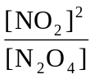 = 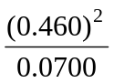 = 3.02
 | Reactants | Products
Mole ratio in the equation | PCl₅ | PCl₃ | Cl₂
n_{i} | 1.85 | 0 | 0
change | –1.48 | +1.48 | +1.48
n_{eq} | 0.370 | 1.48 | 1.48
[ ]_{eq}, V = 2.00 L | 0.185 mol L^{–1} | 0.740 mol L^{–1} | 0.740 mol L^{–1}

K = 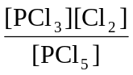 = 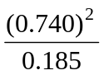 = 2.96
 | Reactants | Products
Mole ratio in the equation | NOBr | NO | Br₂
n_{i} | 2.30 | 0 | 0
change | –1.80 | +1.80 | +0.900
n_{eq} | 0.503 | 1.80 | 0.900
[ ]_{eq}, V = 6.50 L | 0.0774 mol L^{–1} | 0.277 mol L^{–1} | 0.138 mol L^{–1}

K = 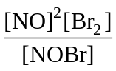 = 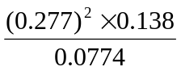 = 0.137

